UMGC Capstone

DevSecOps
  - Guide

TABLE OF CONTENTS
Introduction 4
1. Getting started 5
Setting up your environment using Make 6
2. Git and GitHub 7
Process Overview 7
Criteria for Merging to Master 8
Guide 8
Best Practices 9
3. Testing 10
Expectations 10
Test Examples 11
Integration Test Example 13
Unit Test 13
Writing Testable Code With Dependency Injection 14
How to Uncouple the World 15
4. Coding Standards 16
Java 16
Enforcement 16
Usage 17
5. Code Quality And Security 18
SonarQube 18
Usage 18
6. Deployment 20
Register a Student Azure Account 20
Start Deployment 21
Stop your Deployment 23

Introduction
This document outlines the standards, best practices, and processes that are to be adhered to throughout the course of the UMGC software engineering capstone project by each development team. To be successful in the course, teams will be required to utilize every tool they have acquired throughout the course of their post-graduate education at UMGC. The primary audience of this document is the development teams. This document is intended to guide the development teams on propper practices and ensure development proceeds as smoothly as possible.
This remainder of this document will operate within the context of the UMGC software engineering capstone project context, referring to the business as the class as a whole and project teams as development teams. The purpose of this document is to inform, and thus the remainder of the document will be
Revision History
Name | Date | Reasons for change | Version
Dustin Emerson | 9/5/20 | Initial Draft | V 0.1
Dustin Emerson | 9/12/20 | Add Section on Testing | V 0.4
Taylor Goodlett | 9/13/20 | Start Fleshing Out Style Guide | V 0.5
Taylor Goodlett | 9/15/20 | Fix GitHub Diagram | V 0.6
Dustin Emerson | 9/16/20 | Clean Up | V 0.7
Taylor Goodlett | 9/16/20 | Finalize for initial release to DevTeams | V 0.8
Dustin Emerson | 9/27/20 | Create and release Version 1 | V 1.0
Glenn Goodlett | 10/3/20 | Clean Up | V 1.1
Dustin Emerson | 10/11/20 | Add SonarQube and Spotless | V 2.0
Glenn Goodlett | 10/17/20 | Clean up SonarQube Section | V 2.1
Dustin Emerson | 10/20/20 | Add Deployment Section | V 2.2
Glenn Goodlett | 10/21/20 | Improve Deployment Section | V.2.3
Dustin Emerson | 10/22/20 | Test Guide Instructions | V 2.4
Glenn Goodlett | 10/24/20 | Edit and Finalize | V 2.5
Dustin Emerson | 10/25/20 | Approve for Release | V 3.0

Getting started
Our key goal is to enable the development teams to be successful by shortening the development lifecycle through automated continuous delivery and ensure a high level of quality through automated testing. DeveSecOps encourages all teams to set up their environment how they see fit. However, having the same tools the DevSecOps team is using in the Azure Pipeline will allow you to tap into the benefits of our toolchain on your local machine. The DevSecOps team is utilizing the following tools to build and deploy software:
Required:
- git – Source control (Note: every developer is required to use git)
Optional:
- Linux – Our Operating system (OSX will also suffice)
  - Ways of getting Linux on Windows:
    - Windows Subsystem for Linux (WSL) – Requires Windows 10 professional edition. We recommend Core OS if you are going this route.
    - Oracle VM Virtual Box – Easy to use and free virtual machine to run Linux on.
- Bash – Our shell
- Make – Build automation tool
- Docker – Containerization
Note:
The above tools are not required for you to develop. You are welcome to set up your development environment as you see fit. This is simply a helping hand to get set up. If you are planning on setting up your environment yourself, you can skip the next subsection. Keep in mind you will need to locate and install the dependencies of your application yourself.

Setting up your environment using Make

Requirements:
- Bash
- Make
- Docker

Depending on the project, the make commands could vary. For example, the chatbot team has a separate docker repository with a static database that only has two commands. For this reason, the only command you will ever truly need to get started is the help command:

# Display makes recipes and targets.
~$ make help

Running this command will provide you with the documentation required to set yourself up for success.

Git and GitHub
Throughout the twelve weeks of this course, development teams will use git as their version control system. In addition to git, teams will utilize GitHub for hosting their work, tracking bugs, and facilitating code reviews.

Process Overview
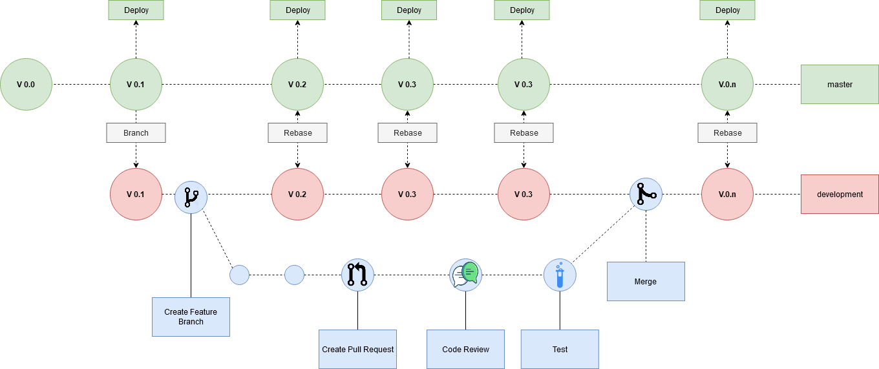
Figure n Version Control Process Overview
Projects repositories will be set up as such:
- There is a mainline master branch that requires a member of DevSecOps to approve code being pushed to it. This branch will be pipelined as such where the project deploys after a build is successful.
- There is a development branch forked off of master. This is the branch the dev teams will use when working. The team can decide how often they wish to move the development branch into master.
Development will be performed using a pull request model. Developers will checkout a new branch on their local machine off of the development branch when they begin developing a new feature. When the feature is ready to be presented for review, they will push their branch to GitHub and create a pull request for peer review. Once a member on their team and a member of DevSecOps has approved, the pull request will be tested. Finally, once passing tests, the branch will be merged into master.

Criteria for Merging to Master
- The pull request must build.
- The code being added must pass a LINT evaluation.
- The code added or changed must be tested.
- The pull request cannot contain any confidential or personal information (passwords, social security, etc.)
- The pull request cannot contain binary files.
- 70%-80% Code Coverage in tests

Guide
- Ensure the repository is cloned on your local machine:
git clone https://github.com/umgc/umgc.project.n.git
- Checkout the development branch:
git checkout development
git pull origin development
- Checkout a new branch for your feature
git checkout -b my-feature
- Develop feature
- Push branch to GitHub
git push origin my-feature
^ This is your branch name from earlier
- Create a pull request on GitHub
  - Follow GitHub's documentation for creating a pull request.
- Incorporate Feedback from team and DevSecOps
- Once the pull request is accepted and tests pass, your work is ready to be merged into production.
  - Follow GitHub's documentation for merging a pull request.

Best Practices
Outside of the process outlined above, which is enforced by rules written by DevSecOps for the repositories, teams are free to use git as they see fit. However, in order to prepare oneself for a career in software development, some best practices are outlined below:
Commit Messages:
Development teams shall do their best to adhere to the git documentation's advice that commits messages shall consist of a "single short (less than 50 character) line summarizing the change, followed by a blank line and then a more thorough description" (Git, 2020).
Branch Names:
Development teams shall do their best to name their branches in such a way that it reflects the purpose of the code added in the merge (i.e., add-context-menu or fix-oom-in-filter).
Changing File Names:
Depending on the case sensitivity of the target file system, you could really destroy someones local repository by making a commit where you change filename.java => FileName.java
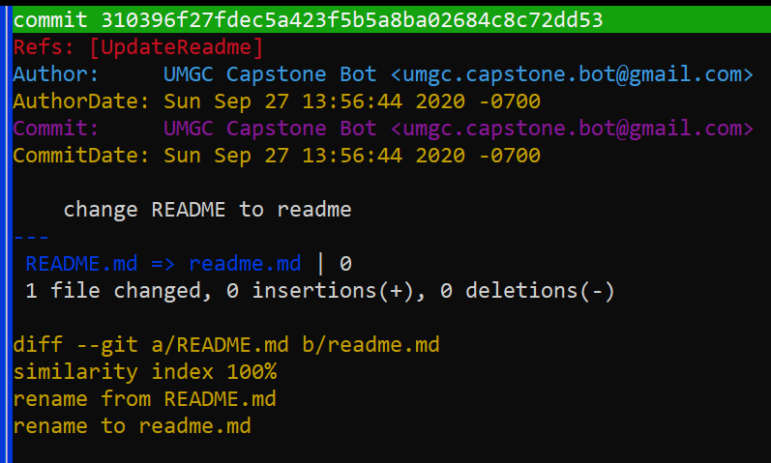
If someone is on a Mac, which is case insensitive but case-preserving, they will be unable to get their operating system to agree that it is up to date with origin. If you must perform the above, either rename it to something unique that has the correct casing or make a commit where you delete the file and make a separate commit on top where you add it back with the correct name.

Testing
In order to ensure the code produces is complete, we require all features to be tested. There are two types of tests we are interested in:
- Integration Tests which tests a collection of components (Required)
- Unit Tests which test a specific component
Sometimes it's very difficult to correctly Unit Test software due to high coupling between classes. In order to not slow down development, at minimum, Integration tests are required. However, one should aspire to have unit tests for their components and integration tests for their features.

The testing framework we will be using is JUnit.

Expectations
We expect the following to be accomplished with your tests.
- Every feature shall at least have an integration Test.
- At least 70% code coverage shall be required.
- Test performance is reliable and does not intermittently fail.
- Tests are atomic and do not require earlier tests to run in order to succeed.
- Tests clean up for themselves. All data produced during test execution shall be cleaned up by the time the test completes.

Test Examples
Below is a simple application written to demonstrate testing software called `AddThings.` The application simply adds objects together. What that means is dependent on the Adder used.
AddThings.java
/**
* Adds objects together if possible
*/
public class AddThings {
private ArrayList<Adder<?>> adders = new ArrayList<>() {{
adders.add(new NumberAdder());
adders.add(new StringAdder());
}};
/**
* Will add two objects together and return the desired result as defined by
* the appropriate Adder
*
* @param an object to be added
* @param b object to be added
* @return a product of adding a and b
*/
Optional<Object> add(Object a, Object b) {
if (!isSameType(a, b))
throw new IllegalArgumentException(
"Objects are not the same type { \n" +
"\t a is " + a.getClass() +
"\t b is " + b.getClass()
);
for (Adder adder : adders) {
if (adder.isType(a)) {
return Optional.of(adder.add(a, b));
}
}
return Optional.empty();
}
/**
* Returns if a
* @param a the object with which to compare its types
* @param b the reference object with which to compare type to a's type
* @return {@code true} if this a's class is the same as the b's class;
* {@code false} otherwise.
*/
boolean isSameType(Object a, Object b) {
return a.getClass().equals(b.getClass());
}
}.
Adder.java
/**
* Adds two objects of type {@code T} together
* @param <T> The type of object the Adder will handle
*/
public interface Adder<T> {
T add(T a, T b);
boolean isType(Object o);
}

NumberAdder.Java
/**
* Adds numbers together, what will they think of next
*/
public class NumberAdder implements Adder<Number> {
/**
* Adds {@param a} and {@param b} together such that
*
* a + b -> c or 1 + 2 -> 3
*
* @param a a number
* @param b another number
* @return the sum of {@param a} and {@param b}
*/
@Override
public Number add(Number a, Number b) {
return a.intValue() + b.intValue();
}
/**
* Determines if the object passed in is a Number
*
* @param o the <i>alleged</i> Number
* @return true if {@param o} is a Number;
* otherwise false
*/
@Override
public boolean isType(Object o) {
return o instanceof Number;
}
}
StringAdder.Java
/**
* Adds strings together, what will they think of next!
*/
public class StringAdder implements Adder<String> {
/**
* Adds, or rather concatenates, {@param a} and {@param b} together such that
*
* a + b -> ab or "Oh Hi" + "Mark" = "Oh HiMark"
*
* @param a a String
* @param b another String
* @return concatenated value of {@param a} + {@param b}
*/
@Override
public String add(String a, String b) {
return a + b;
}
/**
* Determines if the object passed in is a String
* @param o the <i>alleged</i> String
* @return true if {@param o} is a String;
* * otherwise false
*/
@Override
public boolean isType(Object o) {
return o instanceof String;
}
}

Integration Test Example
Integration tests are the easiest to As described above; an integration test shall test a collection of components. For this example, we will be testing AddThings.java using, including its dependency on its Adders.
class AddThingsIntegrationTest{
@Test
public void AddNumber() {
assertEquals(3, new AddThings().add(1, 2).get());
}
@Test
public void AddString() {
assertEquals("TacoPocket",
new AddThings().add("Taco", "Pocket").get());
}
@Test
public void AddNotSupported() {
assertEquals(Optional.empty(), new AddThings().add(new Object(), new Object()));
}
@Test
public void ExceptionThrownWhenArgumentsDoNotMatch() {
assertThrows(IllegalArgumentException.class,
() -> new AddThings().add(1, "Hi Mom"));
}
}

A key aspect that should be noted in the above example is that this test verifies the correctness of the entire suite of components, not just a single class.

Unit Test
A Unit Test, by comparison, will only test a specific component. In this exercise, we will write a unit test for StringAdder.java
class StringAdderTest {
@Test
void add() {
assertEquals("YabbaDabba", new StringAdder().add("Yabba", "Dabba"));
assertEquals("nullDabba", new StringAdder().add(null, "Dabba"));
assertEquals("Yabbanull", new StringAdder().add("Yabba", null));
assertEquals("nullnull", new StringAdder().add(null, null));
}
@Test
void isType() {
assertTrue(new StringAdder().isType("Hi Mom"));
assertFalse(new StringAdder().isType(24));
}
}

Writing Testable Code With Dependency Injection
Often developers develop with the idea of testing as an afterthought, something to be considered when the component is finished being written. Doing so often leads to components that are difficult to debug due to high coupling. In the below guide, we will illustrate how to compose one's component in such a way that dependencies are injected at runtime. This will permit the injection of mock dependencies during test execution.

In the above example, it might occur to you that creating a pure Unit Test for AddThings would be difficult. This is due to the high coupling between AddThings.java and the Adders. This is illustrated here:

public class AddThings {
// We couple AddThings to the Adders here:
private ArrayList<Adder<?>> adders = new ArrayList<>() {{
add(new NumberAdder());
add(new StringAdder());
}};
How could we straighten this up so that we can have a Unit Test for AddThings.java in addition to its integration test? The answer is we can inject the dependencies during its construction.
/**
* Adds objects together if possible
*/
public class AddThings {
// We couple AddThings to the Adders here:
private ArrayList<Adder<?>> adders = new ArrayList<>();
public AddThings() {
this(new NumberAdder(), new StringAdder());
}
// Inject dependency here
AddThings(Adder<?>... adders) {
this.adders.addAll(Arrays.asList(adders));
}

A quick note on what's going on here: Initially, when we first wrote AddThings.java, we baked in the behavior that it had a list of Adders containing an instance of NumberAdder.Java and StringAdder.Java. No matter what we made, that list would contain those instances as soon as the constructor was called. By rewriting the class such that those dependencies are supplied by a default constructor, which in turn would take an array of adders, we have created a loosely coupled class that can have those dependencies supplied if we so wish.

This allows us to inject a mock object into our class during test execution shown below:
class AddThingsTest {
private Adder<String> mockAdder = new Adder<>() {
@Override
public String add(String a, String b) {
return ("taco".equals(a) && "bell".equals(b))
? "taco bell" : "Doritos";
}
@Override
public boolean isType(Object o) {
return o instanceof String;
}
};
@Test
void add() {
assertEquals("taco bell",
new AddThings(mockAdder).add("taco", "bell").get());
assertEquals("Doritos",
new AddThings(mockAdder).add("McDonald's", "milk").get());
}
}

How to Uncouple the World
This practice can be taken even further if you explore functional interfaces. For example, imagine you have a method that is meant to accept a userID and return an email. In order for this to be properly unit tested, we can use the Function Interface.
Instead of thinking of our operation as a call to the database, performing a query, retrieving a result, and returning the email. We can think of it as a function that accepts a String and Returns a String.

import java.util.function.Function;
public class ClassyClass {
private Function<String, String> userEmailProvider;
public ClassyClass() {
Function<String, String> myUserEmailProvider = new Function<>() {
@Override
public String apply(String uid) {
// Connect to database
// query for uid
// return users email
return "taco@timmycorp.com";
}
};
}
// Inject your own email provider here:
ClassyClass(Function<String, String> userEmailProvider) {
this.userEmailProvider = userEmailProvider;
}
}

Coding Standards

Java
We will be conforming to the Google Java Style Guidelines.
https://google.github.io/styleguide/javaguide.html
There are instructions located on the link above for integrating the style guideline with whatever IDE you are using.

Enforcement
Due to the strict timelines we are under; we will not be enforcing syntax guidelines. However, we will provide access to a utility called spotless to make all syntax and style guidelines easy and painless to conform to. We’ve spotless to validate whether or not you are conforming to the Google Java Style Guideline. In addition to validating coding style, spotless can also apply changes to your Java source files to make them conform to the Google Java Style Guideline.

Usage
From your project directory, run the following command:
mvn spotless:check
If your project has any java source files which are not conforming to the style guideline, you will see the following output:
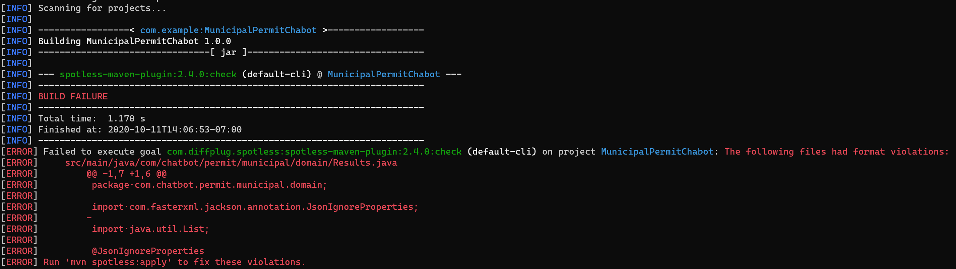
As detailed in the error message, you can tell spotless to fix these changes by running the following command:
mvn spotless:apply
As you can see, now if you run mvn spotless:check again; there will be no errors. You will need to commit these changes and push them to the pull request. Otherwise, the changes will not persist. I suggest having code style changes be committed as a separate commit from your unit of work. This will make reviewing your pull request a lot easier for your peers.
Example of how your commits should look when you clean up your code.
2020-10-11 14:13 -0700 UMGC Capstone Bot o [master] clean up code style
2020-10-11 14:13 -0700 UMGC Capstone Bot | Add taco feature

Code Quality And Security

SonarQube
The plan is for code quality and security will be enforced with SonarQube. SonarQube makes use of static and dynamic code analysis to verify the following:
- Code Reliability
- Code Security
- Code Maintainability

Our SonarQube implementation is hosted on sonarcloud.io at the following address:
https://sonarcloud.io/organizations/umgc-capstone/projects

Usage
Upon creating a pull request, the azure pipeline will automatically run sonarqube and publish the results for your branch. All you need to do is wait for the job to complete on your pull request and go to the address above. Once there, click on your project:
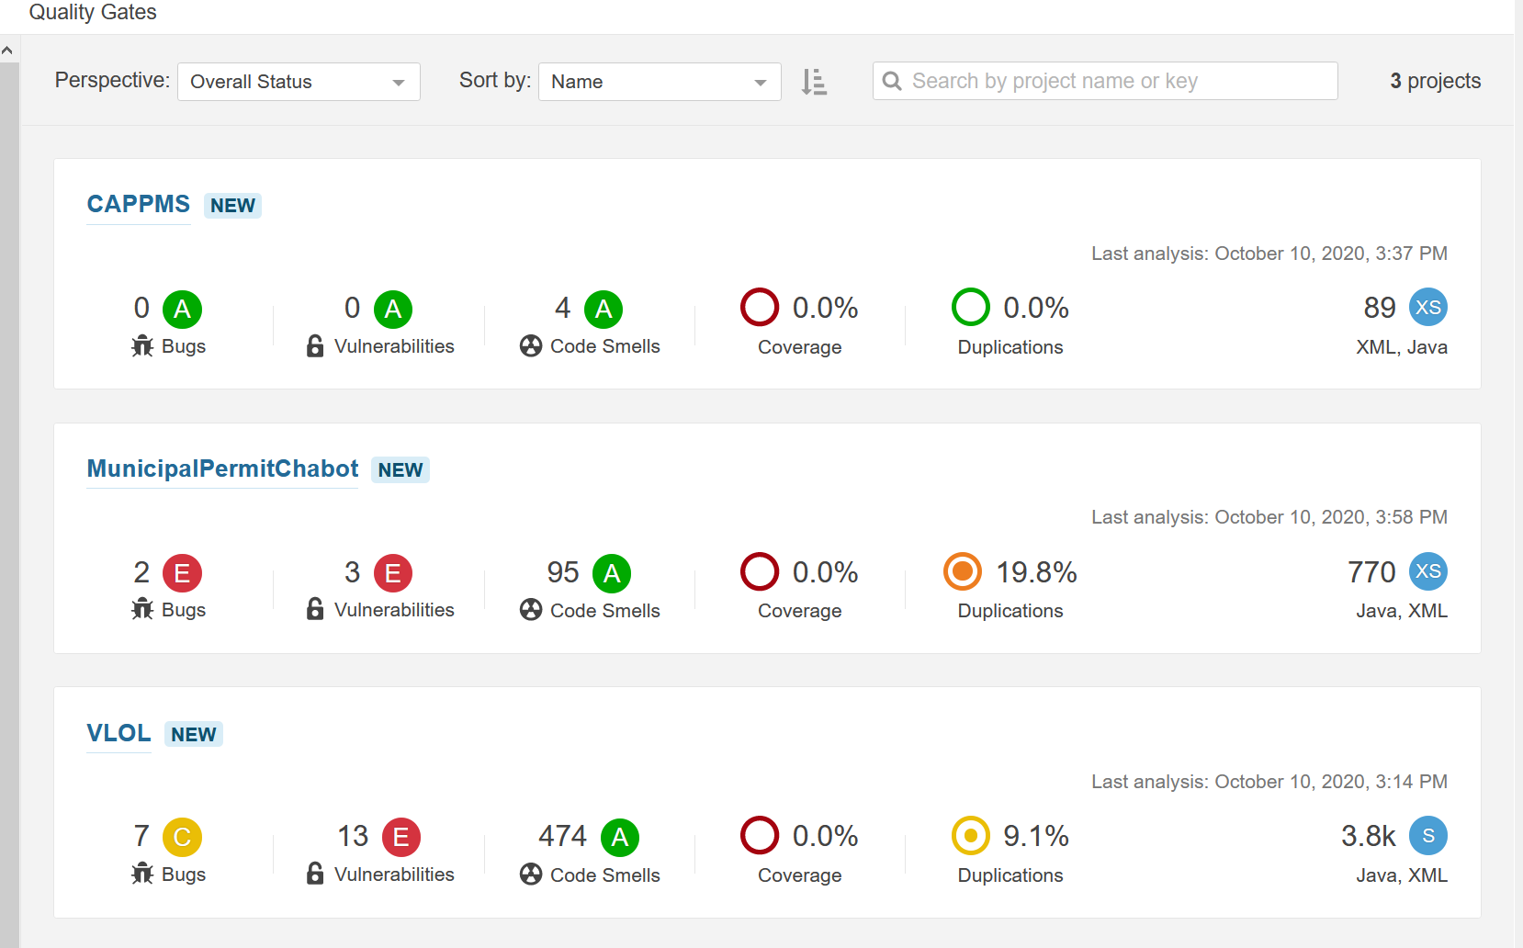
Once you are viewing your project on Sonarcloud, you can change the branch to your development branch by clicking the drop-down next to the project name:
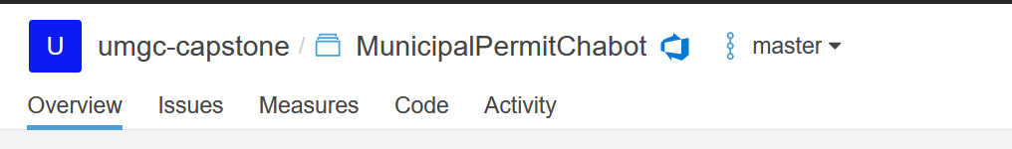
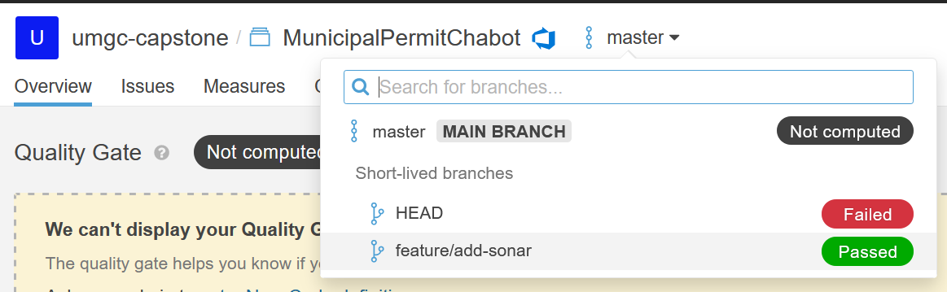

From here, you will be able to navigate and view any issues Sonar detects with your repo and fix them.
As some of the class is inheriting code from other projects, it's suggested that at a minimum, you should not cause any of the metrics to get worse. The best practice would be to collectively make an effort to correct some or all of the issues Sonarqube is noting. Clicking on any of the issues will highlight exactly what's wrong and how to fix it.
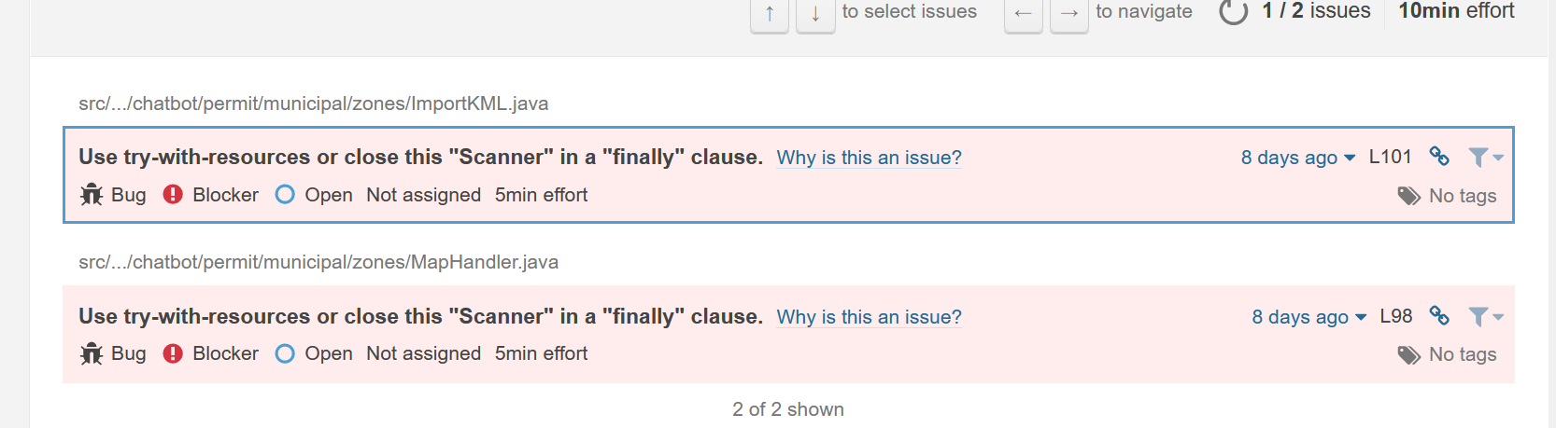

Deployment
Due to financial limitations, each development group will need to run its own deployment from their own student Azure account. To deploy your software, please follow this guide.

Register a Student Azure Account

- Log in to azure.com using your UMGC credentials
- Once logged in, navigate to https://portal.azure.com/#home
- You should now be on the “Welcome to Azure” screen. From here, you will want to click “Explore” under “Access Student Benefits.”
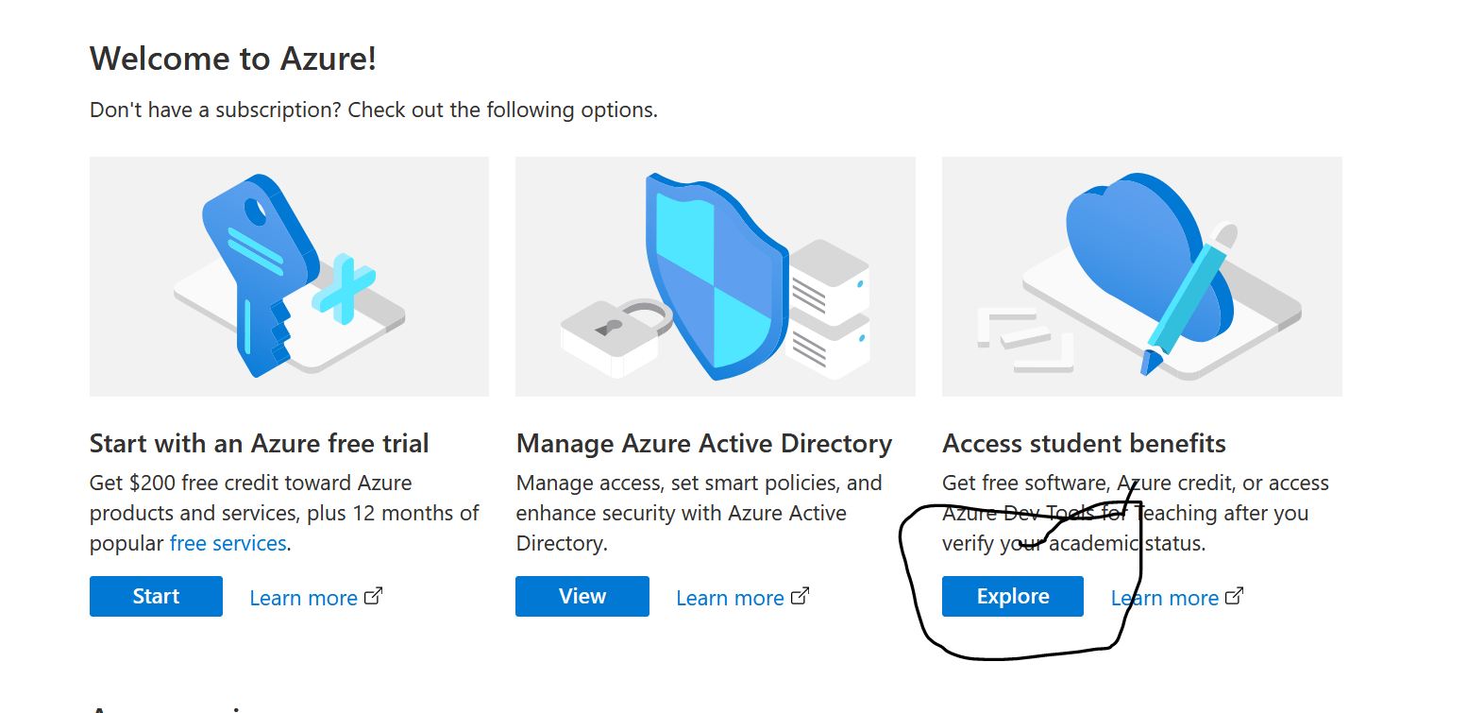

- From here, we want to register for additional student benefits and claim some delicious Azure credit.
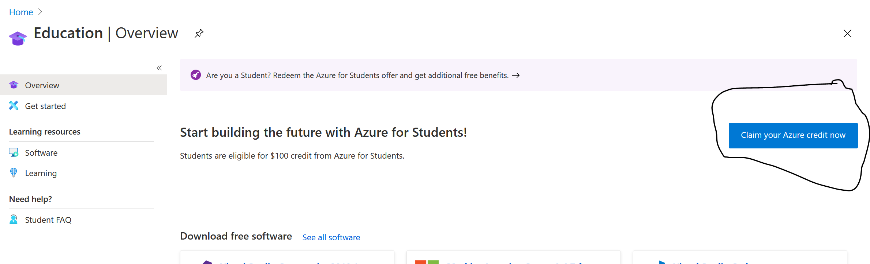

- On this next screen, click “Activate Now.”
- Complete the Identity Verification
- Proceed to the next section.

Start Deployment

- On your local, in your project directory, run `make all.`
- On your local, in your project directory, run `make image`
- On your local, in your project directory, run `make deploy`
  - From here, you will be given information to proceed on your browser:

- docker run -v /home/demerson/school/swen670/umgc.vlol.2/:/repo --entrypoint '/bin/bash' docker.io/umgccaps/advance-development-factory:latest \
-c 'cd /repo && az login && az group create --name devTestGroup --location eastus && \
az deployment group create --resource-group devTestGroup \
--template-file azure/deploy-template.json \
--parameter azure/deploy-parameters.json \
--parameter imageName=docker.io/umgccaps/vlol.app:1.0.121 \
--parameter dnsNameLabel=6c734564b4'
To sign in, use a web browser to open the page https://microsoft.com/devicelogin and enter the code RVEQXVEW6 to authenticate.

- As the above instructions states, navigate to https://microsoft.com/devicelogin and enter the code presented.
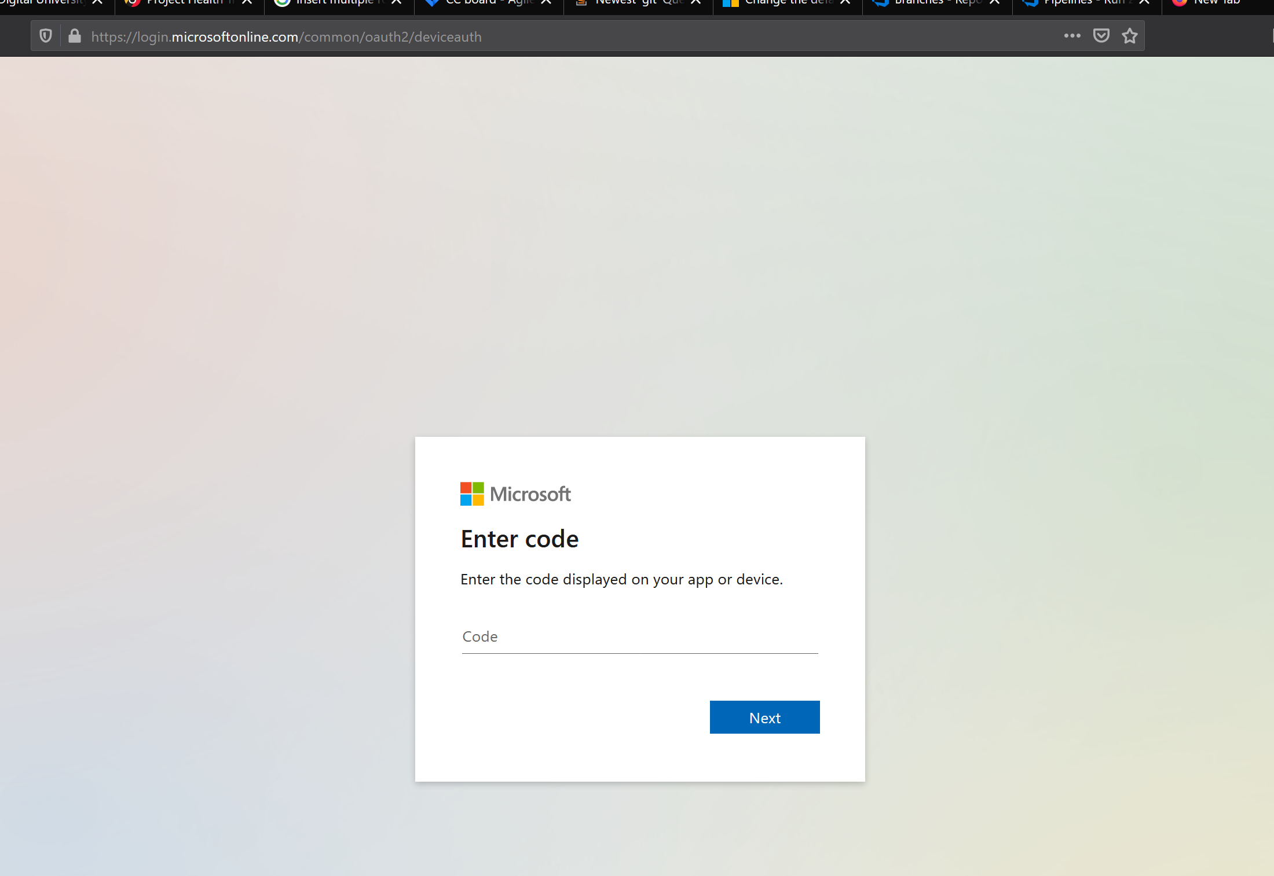
- Now login to the account you just created
- Now look over at your terminal. The application will finish deploying there.
- Once the application finishes running, navigate to the address provided printed first when you ran `make deploy.`
  - Note: if you are declaring an open port such as 5000, you need to add “:5000” at the end of your address.
- You should now see your project running.

Stop your Deployment

- Run `make stop-deploy` to stop your deployment when you are finished. CPU time is money.
  - Just like with `make deploy`, you need to navigate to https://microsoft.com/devicelogin and enter the code provided to shut down your deployment
demerson@DESKTOP-QU0VCD3:~/school/swen670/umgc.vlol.2$ make stop-deploy
docker run -v /home/demerson/school/swen670/umgc.vlol.2/:/repo --entrypoint '/bin/bash' docker.io/umgccaps/advance-development-factory:latest \
-c 'cd /repo && az login && az group delete --name devTestGroup --yes'
To sign in, use a web browser to open the page https://microsoft.com/devicelogin and enter the code FV375WD48 to authenticate.
The following tenants don't contain accessible subscriptions. Use 'az login --allow-no-subscriptions' to have tenant level access.
71c2e1df-5826-4cba-b3fd-2c55ca53cb05

- Once you navigate to that address and enter the code, if you turn your attention back to the terminal, your deployment should finish shutting down, and you will no longer be able to access it from the browser.

